Lab Course Efficient Programming of Multicore Processors and Supercomputers

Task 1 – Compiler Optimization  
Konrad Pröll, Jonas Mayer, Paul Preißner  
May 8, 2017

1.1 Understanding the code

**1. Show the initial performance data.**

Jacobi:

|  |  |
| --- | --- |
| **Resolution** | **MFlop/s** |
| 100 | 475.407468 |
| 300 | 410.097573 |
| 500 | 389.720385 |
| 700 | 345.743325 |
| 900 | 266.359908 |
| 1100 | 245.029018 |
| 1300 | 241.159283 |
| 1500 | 228.631083 |
| 1700 | 217.060715 |
| 1900 | 208.342824 |
| 2100 | 216.940421 |
| 2300 | 189.397070 |
| 2500 | 180.502628 |
| 2700 | 185.770487 |
| 2900 | 176.501386 |

It seems to stabilize at around 180 MFlop/s (Gauss-Seidel: 591.716844 MFlop/s).

**2. Explain how the FLOP/s metric is measured. Which floating point operations are taken into account?**

In heat.c, the number of iterations is counted and multiplied with the resolution of the grid and the factor 11.0, meaning that there are 11 Floating Point Operations per grid point and iteration step.

In void relax_gauss/relax_jacobi(), there are 4 Flops per grid point: Three additions to get the sum of the four points surrounding the calculated grid point, and a multiplication with 0.25, to get the mean. In double residual_gauss/residual/jacobi(), there are 7 Flops: The same four in the calculation of unew, plus one in the calculation of the value to be assigned to diff, (line 41), the value of diff*diff and the sum of that value and sum (both line 42)

1.2 Compiler Options

**What is the meaning of -ipo and -fno-alias?**

*ipo*

An acronym for “Interprocedural Optimization”. When used, ipo analyzes code for various optimizations and applies them where possible. A full list can be found at <https://software.intel.com/en-us/node/522667>

*fno-alias*

Forces the compiler to assume no aliasing. Aliasing is the ability to access a single memory location through different symbolic names. Thus this option has the compiler treat each symbolic name as a unique memory location.

**What is the meaning of "ivdep"?**

*ivdep*

An abbreviation for “ignore vector dependencies”. It is a pragma to be inserted into the code before loops. A compiler might not vectorize because it assumes that there is dependency. On the intel documentation, the example

void ignore_vec_dep(int *a, int k, int c, int m) {

#pragma ivdep

for (int i = 0; i < m; i++)

a[i] = a[i + k] * c;

} (Source: https://software.intel.com/en-us/node/524501)

It is used where a compiler under normal circumstances would not vectorize the loop because the sign of k is not known. This only affects assumed dependencies, not proven dependencies.

**The Intel compiler provides reports when using "opt-report" option. What does it print out, and what does it mean?**

Opt-reports are optimization reports showing which part of the program could be optimized. It shows for each loop whether it was vectorized and if not, explains why. For example, for the function void relax_jacobi the output is:

===========================================================================

Begin optimization report for: relax_jacobi(double *, double *, unsigned int, unsigned int)

Report from: Interprocedural optimizations [ipo]

INLINE REPORT: (relax_jacobi(double *, double *, unsigned int, unsigned int)) [2] relax_jacobi.c(43,1)

Report from: Loop nest, Vector & Auto-parallelization optimizations [loop, vec, par]

LOOP BEGIN at relax_jacobi.c(46,5)

remark #15344: loop was not vectorized: vector dependence prevents vectorization. First dependence is shown below. Use level 5 report for details

remark #15346: vector dependence: assumed OUTPUT dependence between utmp line 50 and utmp line 50

LOOP BEGIN at relax_jacobi.c(48,2)

remark #15344: loop was not vectorized: vector dependence prevents vectorization. First dependence is shown below. Use level 5 report for details

remark #15346: vector dependence: assumed FLOW dependence between utmp line 50 and u line 50

LOOP END

LOOP END

LOOP BEGIN at relax_jacobi.c(59,5)

remark #15344: loop was not vectorized: vector dependence prevents vectorization. First dependence is shown below. Use level 5 report for details

remark #15346: vector dependence: assumed OUTPUT dependence between u line 63 and u line 63

LOOP BEGIN at relax_jacobi.c(61,2)

remark #15344: loop was not vectorized: vector dependence prevents vectorization. First dependence is shown below. Use level 5 report for details

remark #15346: vector dependence: assumed FLOW dependence between u line 63 and utmp line 63

remark #25439: unrolled with remainder by 2

LOOP END

LOOP BEGIN at relax_jacobi.c(61,2)

<Remainder>

LOOP END

LOOP END

===========================================================================

One can see the first loop was not vectorized due to an assumed output (WAW) Dependence in line 50, the second loop was not vectorized due to an assumed flow (RAW) dependence in line 63 but was unrolled by 2. Those hints can be used to set ivdep pragmas.

**Is the code vectorized by the compiler?**

Partially. The inner loop of residual_jacobi is vectorized while no part of the gauss-relaxation is vectorized.

**What is the performance result of these options. Present a graph!**

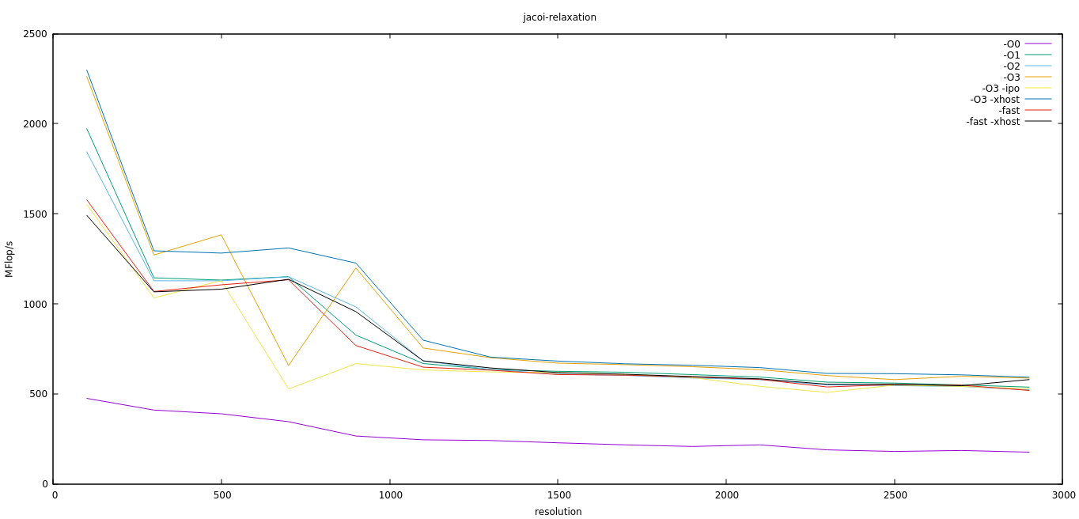

Roughly speaking: -O3 -xhost > -O3 > -O2 > -O1 > -fast -xhost > -fast > -O3 -ipo > -O0

1.3 Batch Processing

**Submit you batch script and the job output from 1.3**

Submitted in separate files.

**Does the performance differ to a run on the login node?**

Generally it does not. However, sometimes the performance on the login node is unusually slow, most likely because someone else is running a program.

1.4 Gprof

**Compile with "-p -g" for use with gprof. A run will produce the file "gmon.out" now. View profiling results with "gprof ./heat gmon.out".**

**Copy the output of gprof into your answer.**

Flat profile:

Each sample counts as 0.01 seconds.

% cumulative self self total

time seconds seconds calls ms/call ms/call name

81.55 101.50 101.50 750 135.33 135.33 relax_jacobi

18.12 124.06 22.56 750 30.08 30.08 residual_jacobi

0.22 124.33 0.27 1 270.00 270.00 write_image

0.05 124.39 0.06 15 4.00 4.00 initialize

0.04 124.44 0.05 1 50.00 50.00 coarsen

0.02 124.47 0.03 __libm_pow_e7

0.00 124.47 0.00 30 0.00 0.00 wtime

0.00 124.47 0.00 15 0.00 0.00 finalize

0.00 124.47 0.00 1 0.00 0.00 print_params

0.00 124.47 0.00 1 0.00 0.00 read_input

//explanation for the output

Call graph (explanation follows)

granularity: each sample hit covers 4 byte(s) for 0.01% of 124.47 seconds

index % time self children called name

<spontaneous>

[1] 100.0 0.00 124.44 main [1]

101.50 0.00 750/750 relax_jacobi [2]

22.56 0.00 750/750 residual_jacobi [3]

0.27 0.00 1/1 write_image [4]

0.06 0.00 15/15 initialize [5]

0.05 0.00 1/1 coarsen [6]

0.00 0.00 30/30 wtime [8]

0.00 0.00 15/15 finalize [9]

0.00 0.00 1/1 read_input [11]

0.00 0.00 1/1 print_params [10]

-----------------------------------------------

101.50 0.00 750/750 main [1]

[2] 81.5 101.50 0.00 750 relax_jacobi [2]

-----------------------------------------------

22.56 0.00 750/750 main [1]

[3] 18.1 22.56 0.00 750 residual_jacobi [3]

-----------------------------------------------

0.27 0.00 1/1 main [1]

[4] 0.2 0.27 0.00 1 write_image [4]

-----------------------------------------------

0.06 0.00 15/15 main [1]

[5] 0.0 0.06 0.00 15 initialize [5]

-----------------------------------------------

0.05 0.00 1/1 main [1]

[6] 0.0 0.05 0.00 1 coarsen [6]

-----------------------------------------------

<spontaneous>

[7] 0.0 0.03 0.00 __libm_pow_e7 [7]

-----------------------------------------------

0.00 0.00 30/30 main [1]

[8] 0.0 0.00 0.00 30 wtime [8]

-----------------------------------------------

0.00 0.00 15/15 main [1]

[9] 0.0 0.00 0.00 15 finalize [9]

-----------------------------------------------

0.00 0.00 1/1 main [1]

[10] 0.0 0.00 0.00 1 print_params [10]

-----------------------------------------------

0.00 0.00 1/1 main [1]

[11] 0.0 0.00 0.00 1 read_input [11]

-----------------------------------------------

//explanation

Index by function name

[7] __libm_pow_e7 [10] print_params [4] write_image

[6] coarsen [11] read_input [8] wtime

[9] finalize [2] relax_jacobi

[5] initialize [3] residual_jacobi

**What is the run-time overhead of "-p"?**

Time measurement spent in each function, tree of function calls, counter of function executions. The overhead can sometimes be more than 260% of the actual execution.

Source: <http://gernotklingler.com/blog/gprof-valgrind-gperftools-evaluation-tools-application-level-cpu-profiling-linux/>

**Which functions take most of the time?**

The actual relaxations, as one would expect due to the higher number of Flops, followed by the calculations of the residuals.